Environment for Auditory Research Manager
Aberdeen Proving Ground, MD 21005

The Army Research Laboratory (ARL) is searching for a hands-on technical manager for its new Environment for Auditory Research (EAR) facility. The successful candidate will be involved in the planning, acquisition, development, and operation of the acoustic and audio systems of the Laboratory. The manager is expected to be involved in the research studies conducted in the laboratory and participate in relevant publications. The position requires knowledge of both analog and digital audio systems, good understanding of spatial acoustics, and familiarity with audio measurement procedures and systems. A master’s degree in engineering, physics, or computer science is expected. A master’s degree in acoustics and knowledge of C/C++ or Matlab are highly desirable. This is a full-time U.S. Government civilian position. Applicants must be U.S. citizens.

BACKGROUND

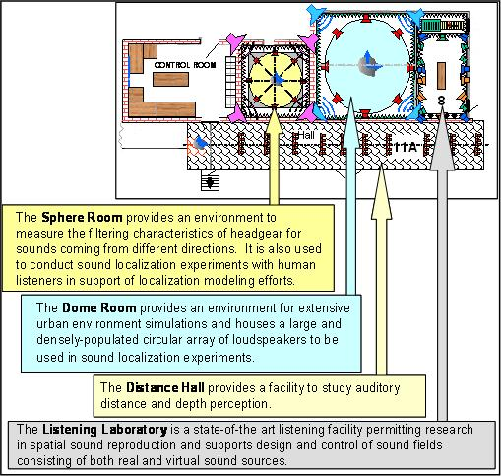
A primary research activity of the Visual and Auditory Processes Branch of the Human Research and Engineering Directorate at the Army Research Laboratory (ARL-HRED) is research in spatial orientation and speech communication in adverse environments. Current and future research studies address the auditory capabilities and limitations of the soldier with respect to the acoustic environment, distance to the place of action, direction, terrain, and soldier equipment. This research is conducted outdoors and in the newly constructed Environment for Auditory Research (EAR), a new research facility dedicated specifically to auditory and audio studies in real and simulated spatial environments. The main applications of the EAR facility are spatial orientation, directional detection, auditory localization, auditory distance estimation, and virtual acoustics studies. This facility will also serve as a center for developing and testing signal processing algorithms for spatial sound as well as a test bed for directional sensory aids and current and future sound recording and reproduction systems. The facility consists of three hemi-anechoic and one reconfigurable laboratory spaces designed to be used in combinations or to run up to four simultaneous separate experiments. The layout and acoustic properties of the space should permit a reasonable simulation of open and urban outdoor environments.

